Project Planning Phase
Project Planning Template (Product Backlog, Sprint Planning, Stories, Story points)
Date | 15 February 2025
Team ID
Project Name | Script-Controlled ACL – Restrict Record Access Based on Field Value
Maximum Marks | 5 Marks
Product Backlog, Sprint Schedule, and Estimation (4 Marks)
Use the below template to create product backlog and sprint schedule
Sprint | Functional Requirement (Epic) | User Story Number | User Story / Task | Story Points | Priority | Team Members
Sprint-1 | Users and Roles Creation | USN-1 | As an administrator, I can create users so that accounts exist for testing and using the access rules. | 2 | High | Divya A
Sprint-1 |  | USN-2 | As an administrator, I can create roles and assign them to users. | 1 | High | Divya A
Sprint-1 | Table Creation | USN-3 | As an administrator, I can create a table with a field that holds the restricted value (e.g., Confidential). | 1 | High | Dharshan Rajaram
Sprint-1 | ACL – READ | USN-4 | As a developer, I can write a script-controlled READ ACL that checks current.<field> and the user’s role. | 5 | High | Dharshan Rajaram
Sprint-2 | ACL – CREATE | USN-5 | As a developer, I can create a CREATE ACL so that only authorized roles can create records. | 3 | High | Dinesh Rajan
Sprint-2 | ACL – WRITE | USN-6 | As a developer, I can create a WRITE ACL so that only authorized roles can edit restricted records. | 3 | High | Dharshini V
Sprint-2 | ACL – DELETE | USN-7 | As a developer, I can create a DELETE ACL so that only authorized roles can delete restricted records. | 2 | Medium | Dharshini V
Sprint-3 | Testing and Verification | USN-8 | As a developer, I can test each ACL by impersonating different users and reading the system logs. | 3 | Medium | Dinesh Rajan
Sprint-2 | Record Access | USN-9 | As a service desk agent, I can open the records I am authorized to see and work on. | 2 | High | Dharshan Rajaram
Sprint-2 |  | USN-10 | As an end user, I can open my own records without being wrongly denied. | 2 | High | Dharshini V
Sprint-3 | Audit Evidence | USN-11 | As an auditor, I can see how access to restricted records is controlled. | 2 | Medium | Dinesh Rajan

Project Tracker, Velocity & Burndown Chart: (4 Marks)
Sprint | Total Story Points | Duration | Sprint Start Date | Sprint End Date (Planned) | Story Points Completed (as on Planned End Date) | Sprint Release Date (Actual)
Sprint-1 | 9 | 6 Days | 17 Feb 2025 | 22 Feb 2025
Sprint-2 | 12 | 6 Days | 24 Feb 2025 | 01 Mar 2025
Sprint-3 | 5 | 6 Days | 03 Mar 2025 | 08 Mar 2025
Velocity:
Imagine we have a 10-day sprint duration, and the velocity of the team is 20 (points per sprint). Let’s calculate the team’s average velocity (AV) per iteration unit (story points per day)
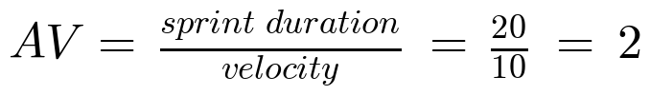
Velocity of our team:
Total story points = 9 + 12 + 5 = 26 and number of sprints = 3, so velocity = 26 / 3 ≈ 8.67 story points per sprint. With a sprint duration of 6 days, the average velocity per day is:
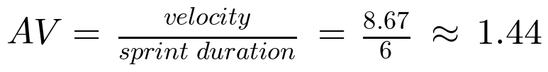
Burndown Chart:
A burn down chart is a graphical representation of work left to do versus time. It is often used in agile software development methodologies such as Scrum. However, burn down charts can be applied to any project containing measurable progress over time.
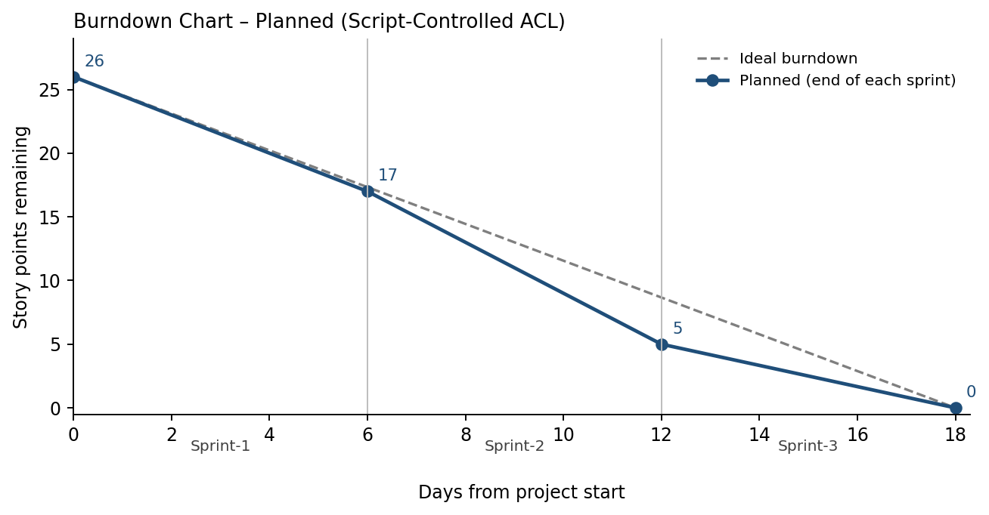
The actual line will be added as each sprint is completed.
https://www.visual-paradigm.com/scrum/scrum-burndown-chart/
https://www.atlassian.com/agile/tutorials/burndown-charts
Reference:
https://www.atlassian.com/agile/project-management
https://www.atlassian.com/agile/tutorials/how-to-do-scrum-with-jira-software
https://www.atlassian.com/agile/tutorials/epics
https://www.atlassian.com/agile/tutorials/sprints
https://www.atlassian.com/agile/project-management/estimation
https://www.atlassian.com/agile/tutorials/burndown-charts

